# 

# 

# Design Report

### **Selected Problem Statement:**

### **Road accidents involving motorcycles are a major concern, particularly during nighttime driving when reduced visibility significantly increases the risk of collisions. This issue is compounded by overspeeding, which limits motorcyclists' ability to accurately assess their surroundings and react in time to avoid hazards. The lack of effective solutions to enhance visibility and situational awareness for motorcyclists at night exacerbates this problem, leading to a higher likelihood of accidents. Current safety measures, such as helmets, reflective vests, and lighting, are not always sufficient in mitigating these risks. The frequency and severity of these accidents point to the urgent need for more effective solutions that can alert riders to dangerous conditions, reduce speed, and improve their situational awareness, ensuring safer driving practices and ultimately preventing fatalities and injuries.**



### **Alignment to Sustainable Development Goals - 9: Industry, Innovation and Infrastructure**

This problem statement aligns with Sustainable Development Goal 9 (SDG 9): Industry, Innovation, and Infrastructure in several ways:

**Infrastructure Development**

1. **Road Safety Infrastructure:** The problem statement highlights the need for improved road safety infrastructure, such as enhanced lighting and visibility systems, to reduce the risk of accidents involving motorcycles.

2. **Innovative Solutions:** The statement emphasizes the need for innovative solutions to enhance visibility and situational awareness for motorcyclists at night, which aligns with SDG 9's focus on promoting innovation and infrastructure development.

**Industry and Innovation**

1. **Development of New Technologies:** The problem statement suggests the need for new technologies and solutions to address the issue of motorcycle accidents at night, which aligns with SDG 9's focus on promoting innovation and entrepreneurship.

2. **Improvement of Existing Safety Measures:** The statement also highlights the need to improve existing safety measures, such as helmets and reflective vests, which aligns with SDG 9's focus on promoting industry innovation and upgrading.

**Quality, Reliable, Sustainable, and Resilient Infrastructure**

1**. Reducing Road Accidents:** The problem statement aims to reduce road accidents involving motorcycles, which aligns with SDG 9's focus on promoting sustainable and resilient infrastructure.

2. **Enhancing Road Safety**: The statement emphasizes the need to enhance road safety, which aligns with SDG 9's focus on promoting quality, reliable, sustainable, and resilient infrastructure.

By addressing the issue of motorcycle accidents at night, this problem statement contributes to the achievement of SDG 9 by promoting innovation, infrastructure development, and industry upgrading, ultimately leading to improved road safety and reduced accidents.

## 

## **Part I - Analysis of End-User**

**End User: Road users, including drivers, passengers, pedestrians, and cyclists.**

**User problem: Road accidents resulting in injuries, fatalities, and economic losses.**

**Why is the problem important to solve?**

1. **Human Cost:** Road accidents claim millions of lives worldwide each year, causing immense emotional trauma to families and communities.
2. **Economic Burden:** Road accidents result in significant economic losses, including medical expenses, lost productivity, and damage to infrastructure.
3. **Social Impact:** Road accidents can lead to social isolation, reduced mobility, and decreased quality of life for victims and their families.

**Other Stakeholders:**

1. **Government Agencies**: Responsible for road safety regulations, infrastructure development, and enforcement.
2. **Automotive Industry:** Manufacturers of vehicles and safety equipment.
3. **Insurance Companies:** Providers of coverage for road accidents.
4. **Emergency Services:** Responders to road accidents, including police, ambulance, and fire services.
5. **Healthcare Providers:** Treating injuries and providing medical care to accident victims.

**Survey Methodology and Results**

As part of our research on road accidents at nighttime, we conducted a survey to gather insights from drivers on their nighttime driving habits, safety measures, and experiences with road accidents.

**Survey Design and Administration**

The survey consisted of 14 questions, divided into five sections: demographic information, nighttime driving habits, road accident experience, safety measures, and suggestions for improvement. The survey was administered online and in-person to a sample of [insert number] drivers.

**Questionnaire:**

**Section 1: Demographic Information**

1. What is your age? _____
2. Do you own a vehicle?

A. Yes

B. No

**Section 2: Nighttime Driving Habits**

1. How often do you drive at night?
2. Daily
3. Occasionally
4. Rarely

4. What time of night do you usually drive?

1. Peak hours (7-10 pm)
2. Late evening (10 pm-1 am)
3. Early morning (1-5 am)

5. Do you use headlights while driving at night?

1. Always
2. Sometimes
3. Rarely

**Section 3: Road Accident Experience**

5. Have you ever been involved in a road accident at night?

A. Yes

B. No

6. If yes, how many accidents have you been involved in? _____

7. What was the main cause of the accident?

1. Speeding
2. Reckless driving
3. Poor visibility
4. Other (please specify) _____

8. Were you injured in the accident?

1. Yes

2. No

**Section 4: Safety Measures**

9. Do you wear a seatbelt while driving at night?

A. Always

B. Sometimes

C. Rarely

10. Do you use fog lights or high beams while driving at night?

A. Always

B. Sometimes

C. Rarely

**Section 5: Suggestions for Improvement**

11. What do you think can be done to reduce road accidents at night?

1. Improved lighting
2. Better Road conditions
3. Stricter Law enforcement
4. Other:

12. Do you think there should be more public awareness campaigns about nighttime driving safety?

1. Yes
2. No

13. Any other suggestions?

(Open-ended question for respondents to provide additional suggestions)

By understanding the end-user's problem and the stakeholders involved, we can develop effective solutions to reduce road accidents and improve road safety.

**Insights From the user interaction:**

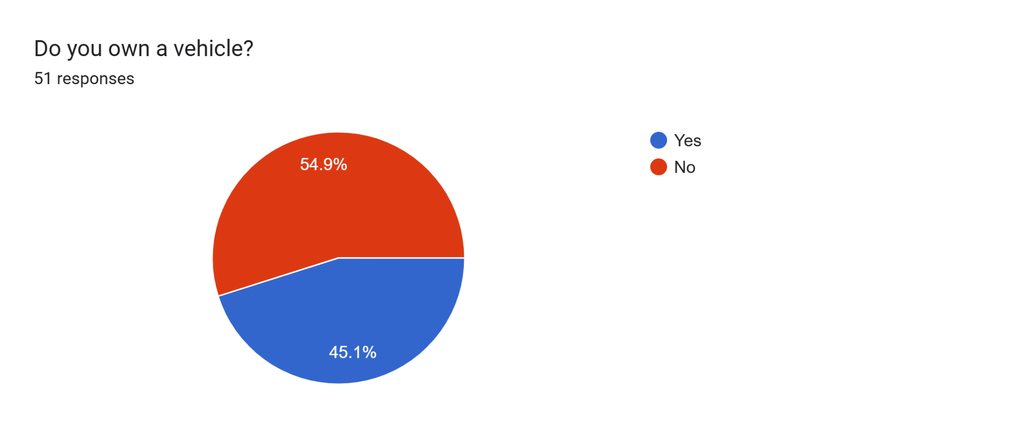

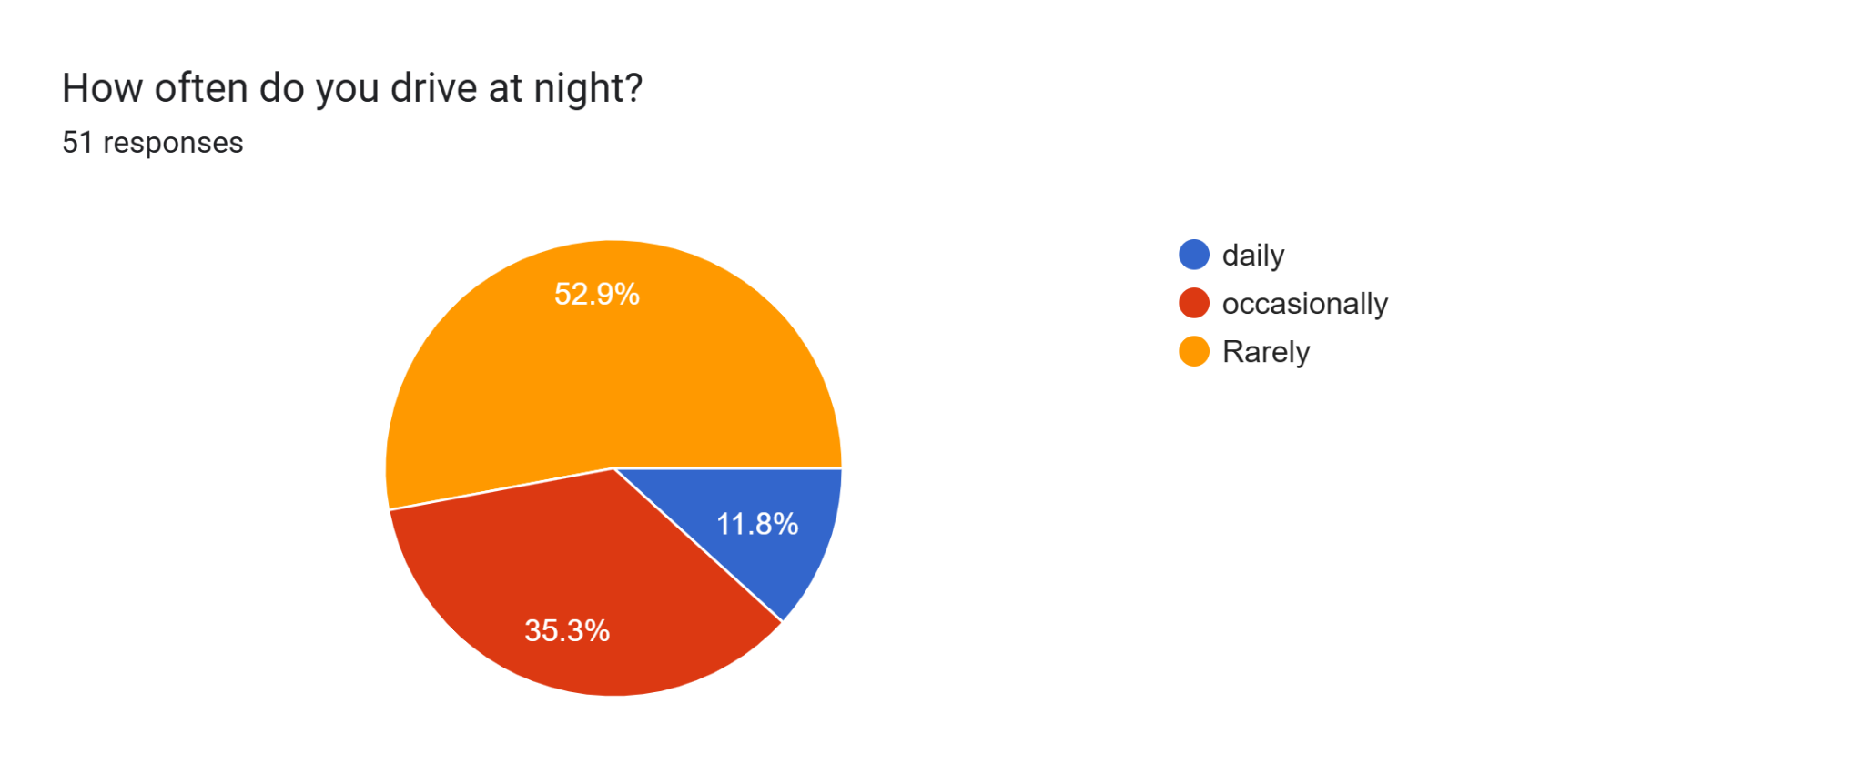

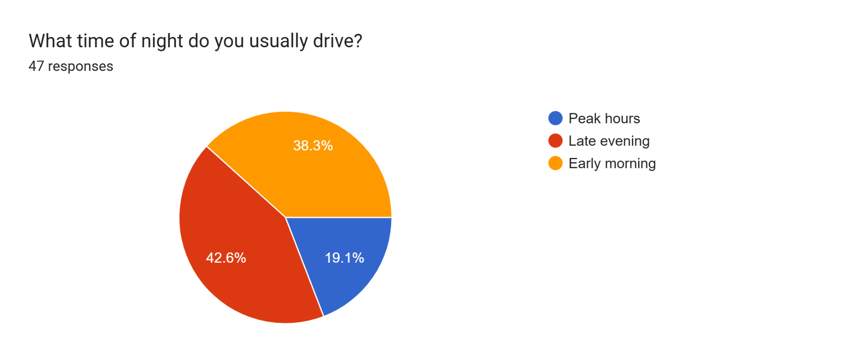

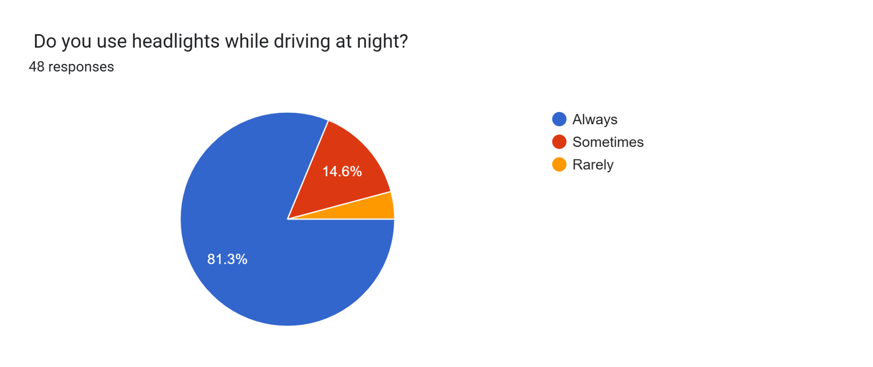

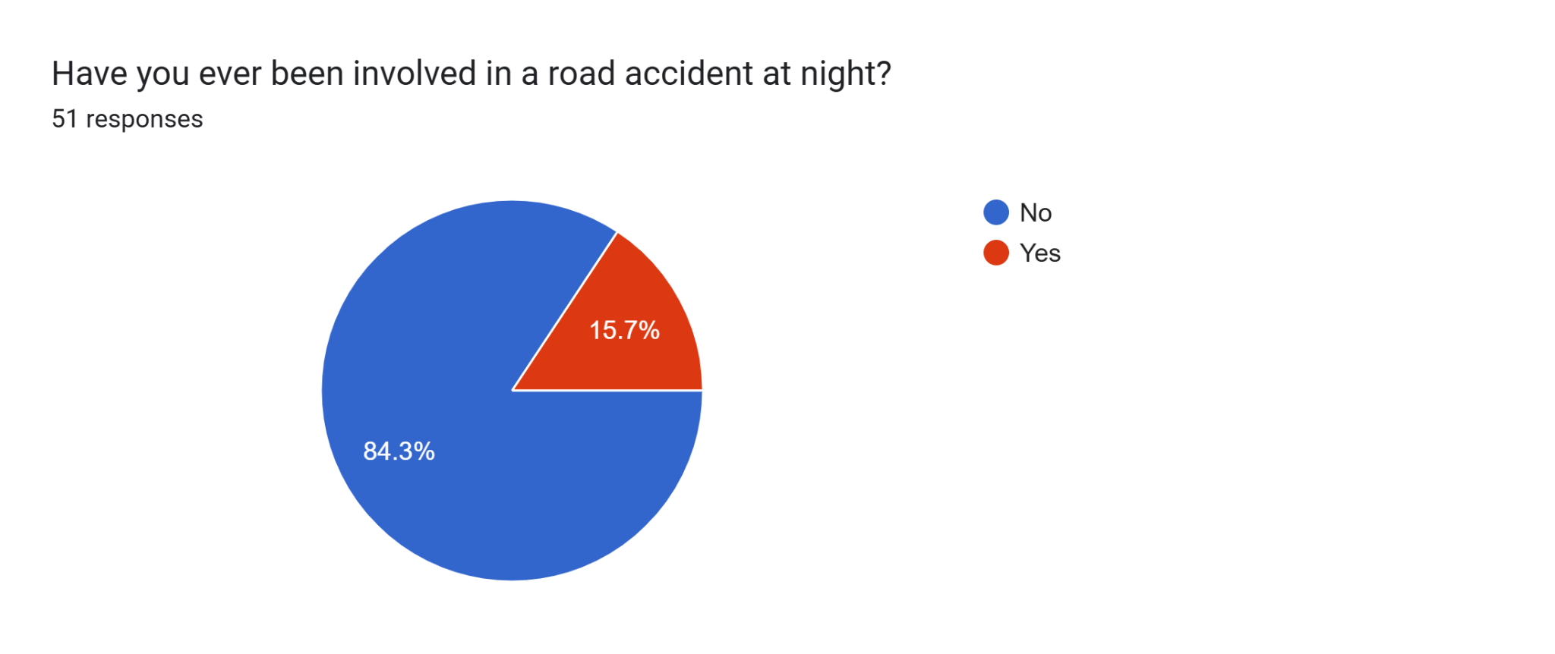

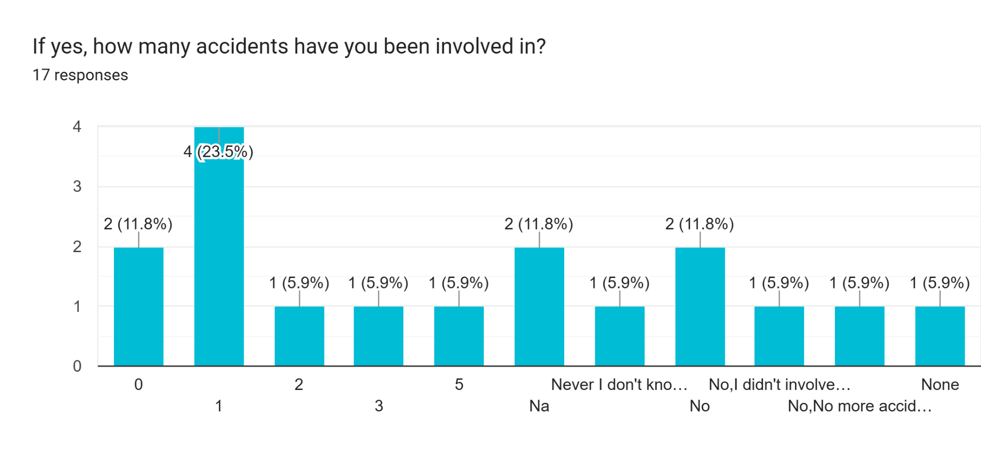

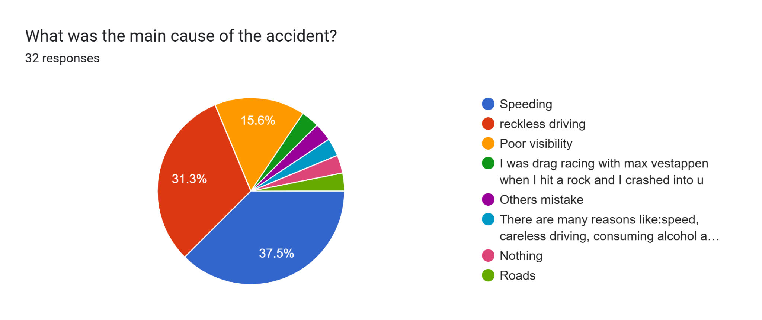

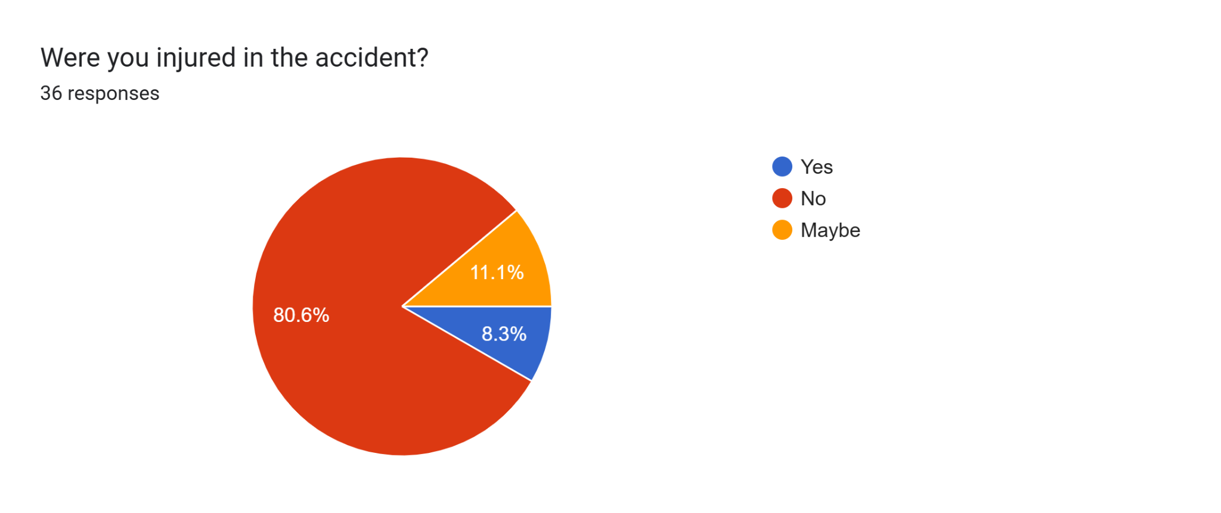

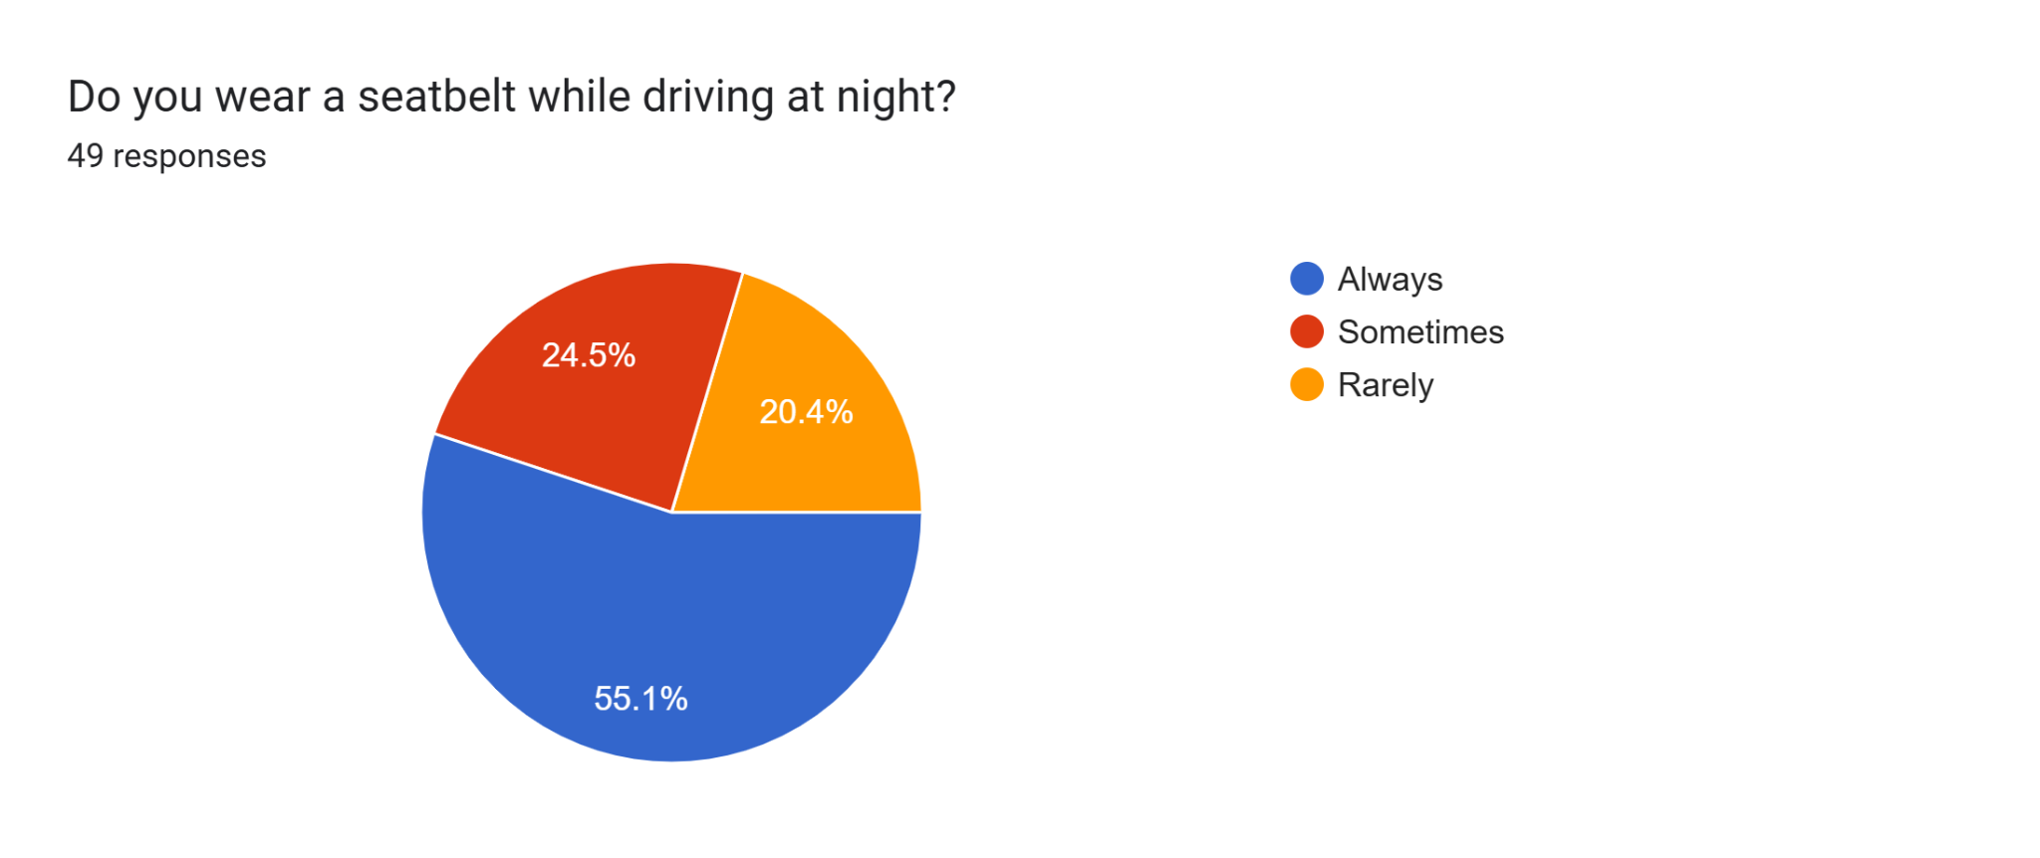

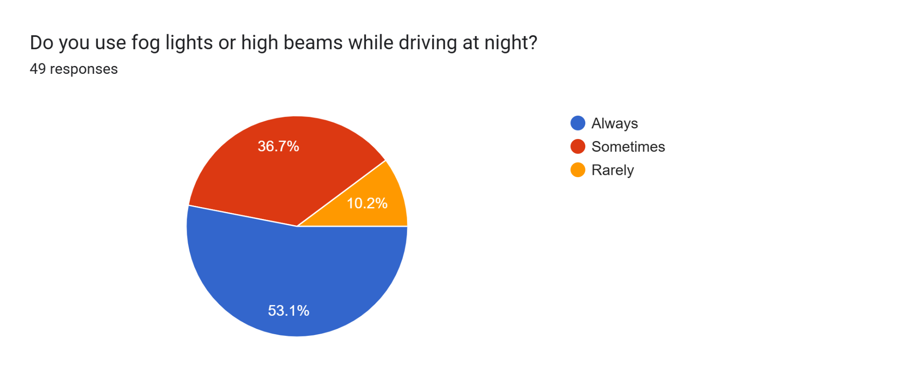

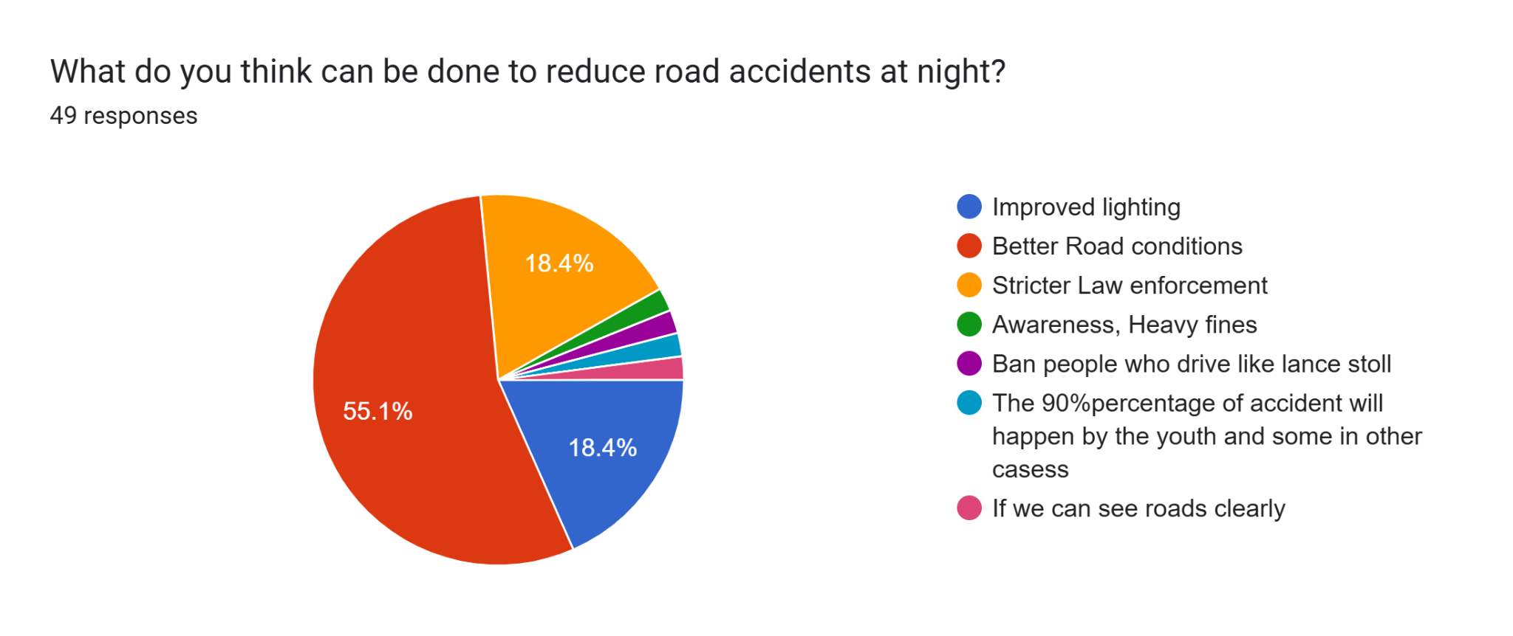

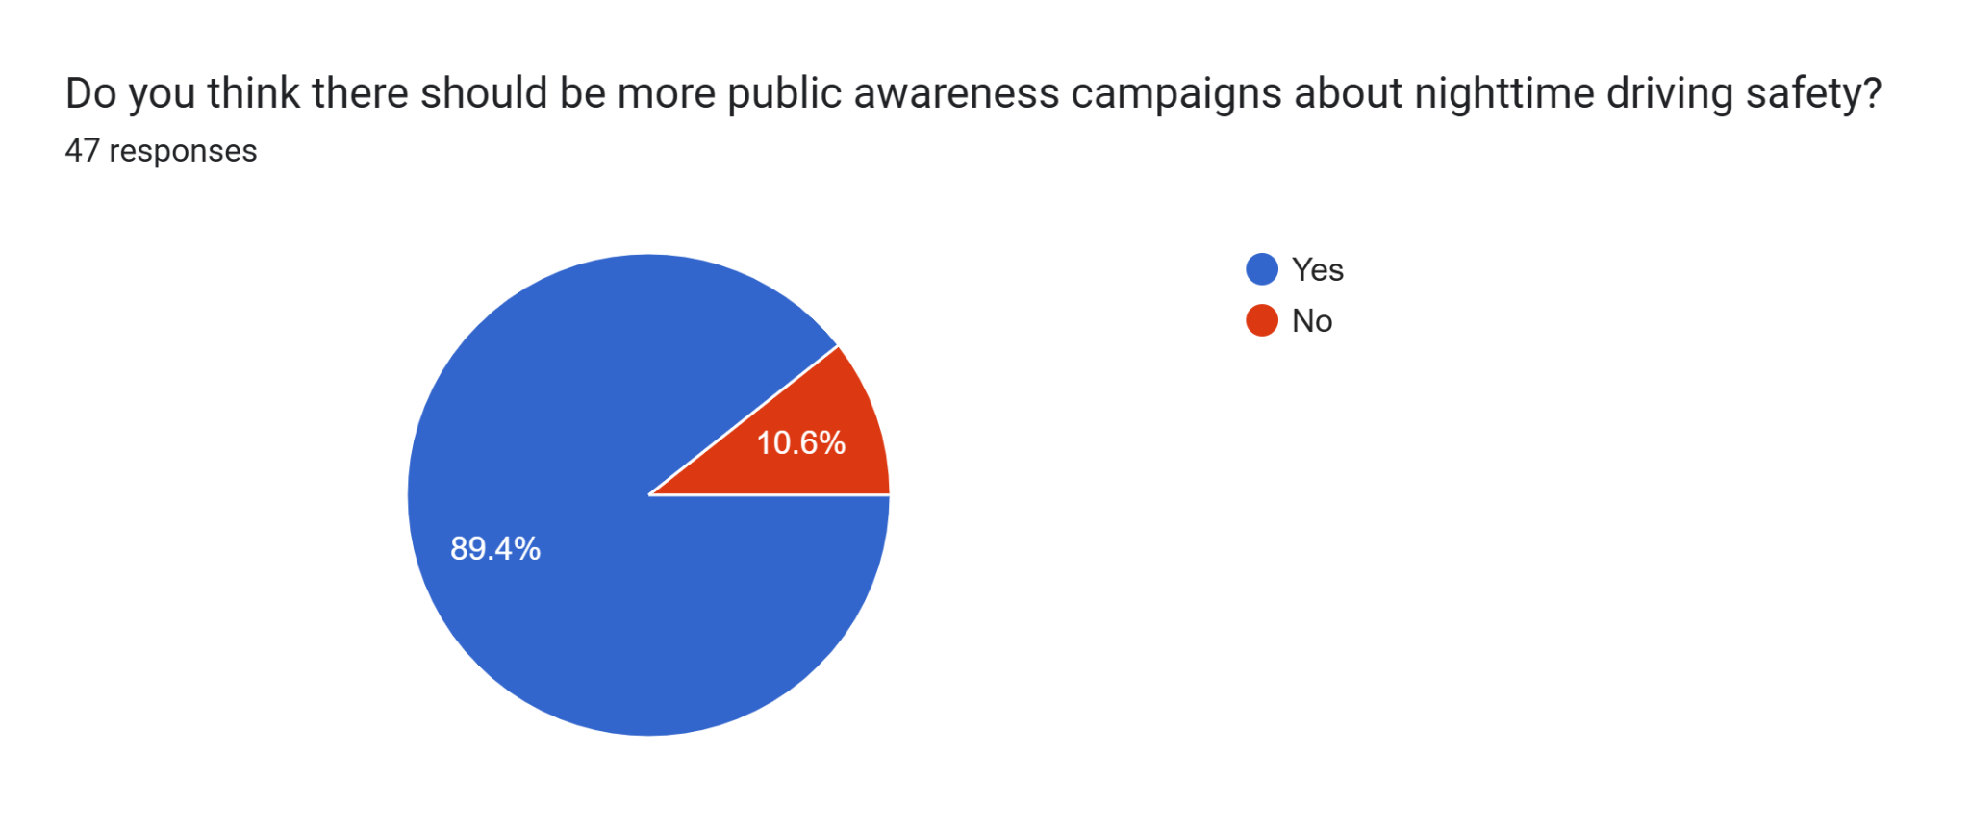

## 

## 

## 

## 

## **Part II - Problem Scoping to Identify Design Requirements**

**Insights from User Interaction:**

1. Drivers, pedestrians, and cyclists face visibility challenges at nighttime, increasing the risk of accidents.
2. Insufficient lighting on roads and sidewalks contributes to accidents.
3. Distracted driving and speeding are common causes of nighttime accidents.
4. Emergency services and medical treatment are critical in the event of an accident.

- **What do users need or want?**

1. Improved visibility and safety at night.
2. A system that minimizes distractions but enhances awareness.
3. An affordable, low-maintenance solution.
4. Reliable, durable infrastructure or device that can be used year-round.

**Criteria (Design Requirements):**

1. **Efficiency :** Reduce the number of nighttime accidents by 20% within the first year of implementation.
2. **Ease of Use:** Design a solution that is intuitive and easy to use for drivers, pedestrians, and cyclists.
3. **Cost:** Develop a cost-effective solution that can be implemented within a budget of 5,00,000 Rupees.
4. **Durability:** Design a solution that can withstand various weather conditions and last for at least 5 years.
5. **Safety:** Ensure the solution does not create new hazards or distractions for road users.

**Constraints:**

1. **Infrastructure:** Solution must be compatible with existing road infrastructure.
2. **Regulations:** Comply with local and national regulations regarding road safety and lighting.
3. **Environmental Impact:** Minimize environmental impact and avoid disrupting local ecosystems.
4. **Maintenance:** Design a solution that requires minimal maintenance and upkeep.

### **Evaluation of Solution proposed based on Design Requirements**

1. **Criteria:**

|  |  |  |
| --- | --- | --- |
| **Criteria** | **Design Metric** | **Unit** |
| Efficiency | Accident reduction rate | 55-75% |
| Ease of Use | User feedback on usability | 9/10 |
| Cost | Implementation of cost | 16,500Rupees |
| Durability | Lifespan of Solution | 7-10Years |
| Safety | Incident reports after implementation | 0 |

1. **Constraints:**

|  |  |  |
| --- | --- | --- |
| **Constraints** | **Design Metric** | **Unit** |
| Budget | Total cost | 20,000Rupees |
| Regulations | Compliance Rate | 90% |
| Environmental Impact | Carbon footprint and environmental disruption | 20-150 g CO2/kWh, environmental disruption  3/10 |
| Maintenance | Frequency of maintenance required | Maintenance intervals  6 months |

## 

## 

**Part III: Ideation**

**Our team generated a list of innovative ideas to address the problem of road accidents at nighttime. Here are the different ideas we drafted:**

1. **Smart Road Lighting System:** Implement an intelligent road lighting system that adjusts brightness and color based on real-time traffic conditions, weather, and time of day.

2. **Glow-in-the-Dark Road Markings**

Apply glow-in-the-dark materials to road markings, pedestrian crossings, and traffic signs to increase visibility at nighttime.

3. **Driver Alert System**

Develop a driver alert system that uses sensors and cameras to detect potential hazards, such as pedestrians, animals, or obstacles, and alerts drivers through visual and auditory warnings.

4. **Smart Pedestrian Crossing**

Design a smart pedestrian crossing that uses sensors and LED lights to detect pedestrians and alert drivers, providing a safer crossing experience.

## **Part IV - Final Solution Proposed**

### ***Solar panel street lights***

**Justification:**

We selected this idea because it addresses the root cause of nighttime accidents: poor visibility. By constructing solar street lights , we can significantly improve visibility, reduce accidents, and enhance overall road safety. This solution also integrates safety features, making it a comprehensive approach to addressing nighttime road safety.

**3D model of the proposed idea:**

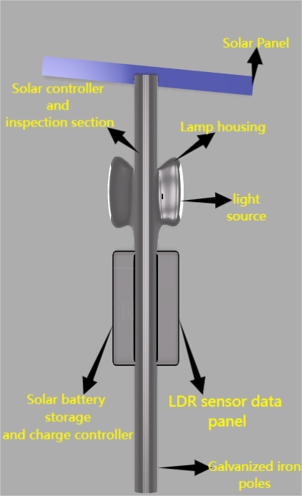

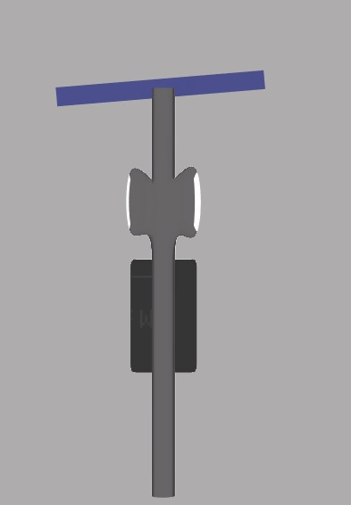

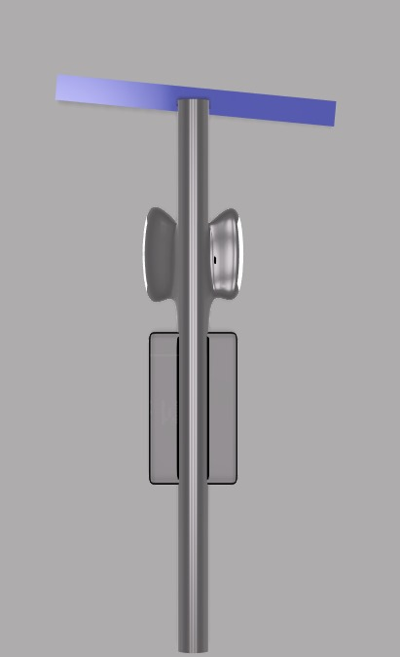

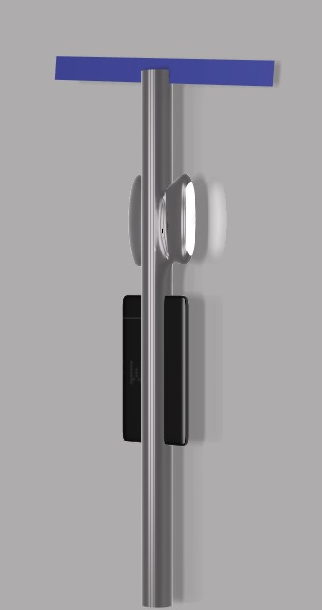

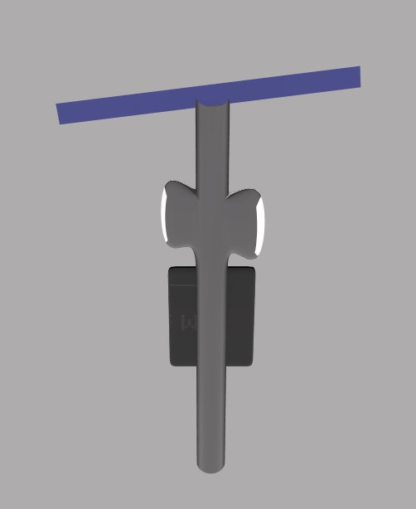

**Description:**

**Automatic street lights are a common sight in urban and suburban areas, providing illumination during the night and switching off automatically during the day. These lights incorporate a built-in sensor, typically a photoresistor or light-dependent resistor (LDR), that detects changes in ambient light levels.**

**Components:**

1. **Solar Panels:** High-efficiency solar panels to harness renewable energy and power the lighting system.

2. **LED Lighting:** Energy-efficient LED lights with adjustable brightness and color temperature to optimize visibility and minimize energy consumption.

3. **Smart Sensors**: Advanced sensors to detect and respond to real-time traffic conditions, weather, and road hazards.

**Features:**

1. **Autonomous Operation:** The system operates autonomously, adjusting lighting conditions based on real-time data.

2. **Energy Efficiency:** Solar panels and energy-efficient LED lights minimize energy consumption and reduce carbon emissions.

3. **Improved Safety:** Smart sensors and AI-powered control system enhance safety by detecting potential hazards and adjusting lighting conditions accordingly.

**How They Work**

* **Dusk:** As the sun sets and the ambient light intensity decreases, the LDR's resistance increases.
* **Threshold Reached:** When the resistance of the LDR reaches a predetermined threshold, the sensor triggers a relay or switch.
* **Light Activation:** The relay or switch connects the power supply to the lamp, turning it on.
* **Dawn:** As the sun rises and the ambient light intensity increases, the LDR's resistance decreases.
* **Light Deactivation:** When the resistance falls below the threshold, the sensor triggers the relay or switch again, disconnecting the power supply and turning off the lamp.

**Benefits:**

1. **Reduced Energy Consumption:** Solar panels and energy-efficient LED lights minimize energy consumption and reduce carbon emissions.

2. **Improved Safety:** Smart sensors and AI-powered control systems enhance safety by detecting potential hazards and adjusting lighting conditions accordingly.

3. **Increased Efficiency**: Autonomous operation and real-time monitoring optimize energy efficiency and reduce maintenance costs.

4. Enhanced Sustainability: Solar-powered systems reduce reliance on fossil fuels and promote sustainable energy practices.

## **Part V – Conclusion and Future Scope**

**Conclusion:**

Our project focused on designing a sustainable and innovative solution to reduce road accidents at nighttime. Through research, ideation, and prototyping, we developed a Solar-Powered Smart Street Lighting System. This system combines energy-efficient LED lighting with solar panels and smart sensors to provide a reliable, adaptive, and safe lighting solution for roads and public spaces.

**Key Takeaways:**

1. Solar-powered street lights offer a sustainable and energy-efficient solution for outdoor lighting.

2. Smart sensors and AI-powered control systems can enhance safety and optimize energy efficiency.

3. Innovative design and technology can improve road safety and reduce accidents.

**Future Scope:**

1. **Integration with Existing Infrastructure:** Collaborate with municipalities and transportation agencies to integrate our system with existing infrastructure.

2. **Expansion to Other Applications:** Explore applications in rural areas, parking lots, and pedestrian walkways.

3. **Advanced Sensor Technologies:** Integrate advanced sensor technologies, such as lidar and radar, to enhance safety and detection capabilities.

4. **Energy Storage and Grid Integration:** Develop more efficient energy storage systems and explore grid integration options to optimize energy efficiency.

5. **Public Awareness and Education:**Launch public awareness campaigns to educate drivers, pedestrians, and cyclists about the importance of road safety and the benefits of our system.